Environmental Studies

## END TERM REPORT

*BY*

Sai Navya, K.Tharun , Umesh Kumar

(Section: -KOC37)

Roll no: - A01, A02, A03



Department of Intelligent Systems School of Computer Science Engineering Lovely Professional University, Jalandhar December-2022



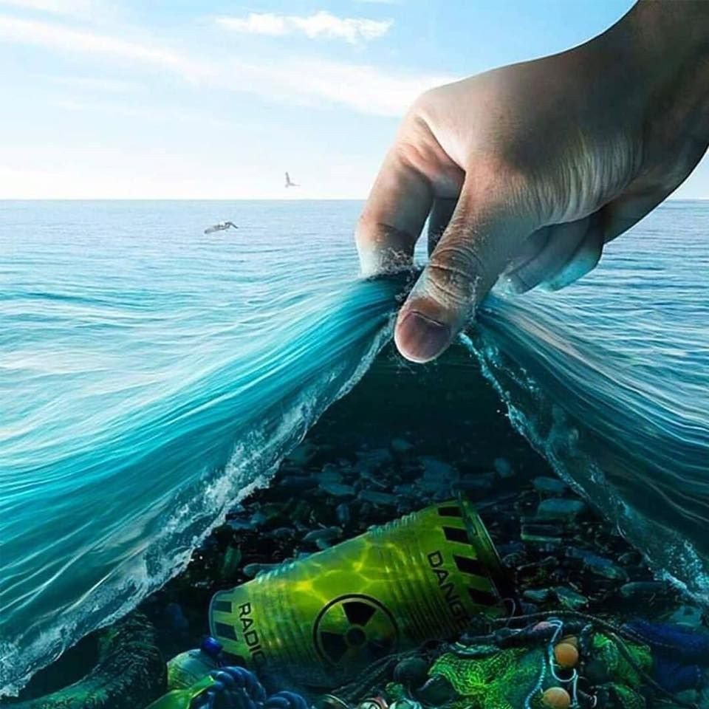

**ENVIRONMENTAL STUDIES**

**PROJECT REPORT**

**WATER POLLUTION**

# ACKNOWLEDGEMENT

I would like to express my special thanks and gratitude to my teacher who gave me the golden opportunity to do this wonderful project, which also helped me to do new things and I came to know about so many new things. I am really thankful to them.

I would like to express my gratitude towards my parents who helped me a lot in finalizing this project within the limited time frame.

My thanks and appreciation also goes to my friends in developing the project and to the people who have willingly helped me out with their abilities.

**Thank You**

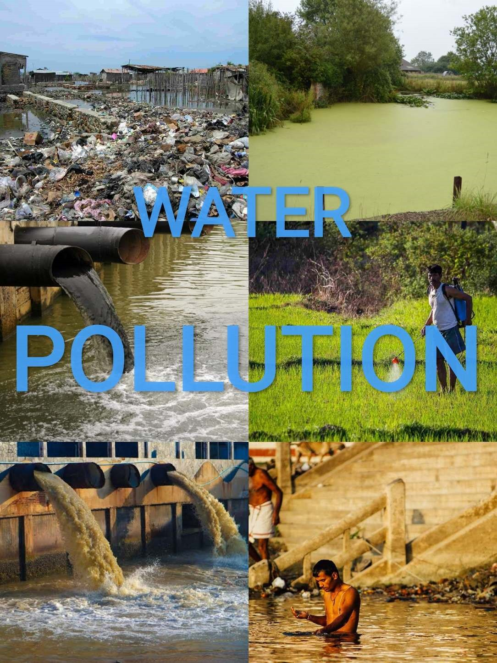

## INTRODUCTION

We know water’s another name is life. Water is one of the most important natural resources, which is absolutely essential in having life and living life. A part from sustaining life, water is used for various essential purposes. And water pollution is again a major global problem, which harms the comfortable living of us.

It has been proved that water pollution is a major cause of death and disease worldwide. In the world everyday more than 1400 people die for water pollution only. The amount of water pollution in India has increased to such an extent that it has become serious and many people are suffering from various diseases due to this water pollution.

## WATER POLLUTION

Water pollution is the contamination of water in water bodies such as rivers, oceans, lakes, and swamps. This means that one or more substances have built up in water to the extent of causing problems to people, animals and plants.

Addition of certain substances to the water such as organic, inorganic, biological, radiological heat which degrades the quality of water so that it becomes unfit for use. Water pollution is not only confirmed to surface water, but it has also spread to ground water, sea and ocean.

### Water Resources On Earth

About three fourths of our planet earth’s surface is covered by water. However, very little of it is available for consumption. Most (about 97%) of the water on the earth is present in the seas and oceans. It is too salty to be of any use for drinking, agriculture and industrial purposes. The remaining 3% and fresh water. 75% of which is locked up in the polar ice caps and in glaciers and quite deep under the earth’s surface as underground water. The fresh water, which we can use, comes to us from two sources:

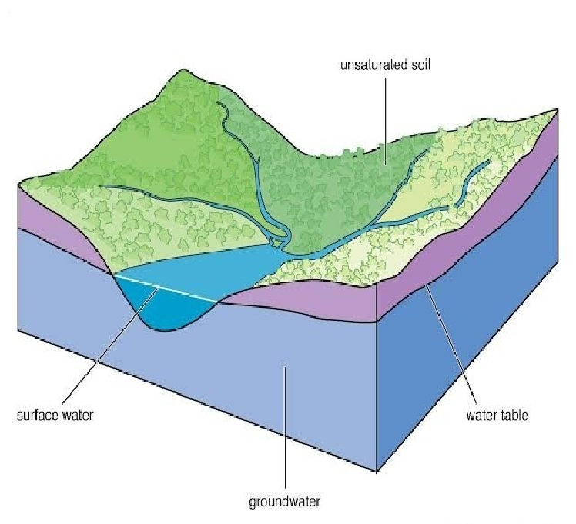**1. Surface water 2. Ground water**

#### 1.Surface Water

Rain and snow are good natural resources of fresh water. It is estimated that of all the precipitation (rain water and snow) that falls on the earth, about one-third is absorbed by the plants and another one-third seeps down into the soil and the remaining one-third runs off the surface into streams and rivers. This part of precipitation, which runs off to form streams, rivers and lakes, is called the surface water.

#### 2.Ground Water

The part of precipitation that seeps into the ground as a result of gravity and fills the pores between soil particles and rocks under it is called ground water.

### Water Pollution Parameters

Water may be called polluted when the following parameters stated reach beyond a specified concentration in water.

#### 1.Physical Parameter

Colour, order, turbidity, taste, temperature and electrical conductivity constitute the physical parameters and are good indicators of contamination.

For instance colour and turbidity are visible evidences of polluted water while an offensive odour or a bitter and difference than normal taste also makes water unfit for drinking.

#### 2.Chemical Parameters

These include the amount of carbonates, sulphates, chlorides, fluorides, nitrates and metal ions. These chemicals form the total dissolved soils, present in water.

#### 3.Biological Parameters

The biological parameters include matter like algae, fungi, viruses,prototozoa and bacteria. The life forms present in water are effected to a good extent by the presence of pollutants. The pollutants in water may cause a reduction in the population of both lower and higher plants and animals lives. Thus, the biological parameters give an indirect indication of the amount of pollution in water.

### Cause of Water Pollution

There are many reasons for water pollution. They are discussed below.

#### 01.Sewage and Domestic Wastes

The sewage and waste water that is produced by each household is chemically treated and released in to sea with fresh water. The sewage water carries harmful bacteria and chemicals that can cause serious health problems. Pathogens are known as a common water pollutant; The sewers of cities house several pathogens and thereby diseases. Microorganisms in water are known to be causes of some very deadly diseases and become the breeding grounds for other creatures that act like carriers. These carriers inflict these diseases via various forms of contact onto an individual. A very common example of this process would be Malaria.

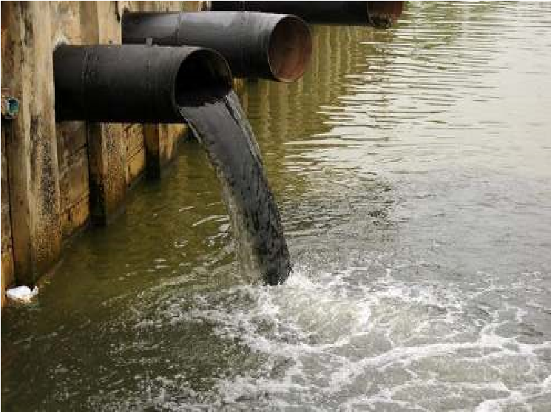

**02**

**.Industrial waste**

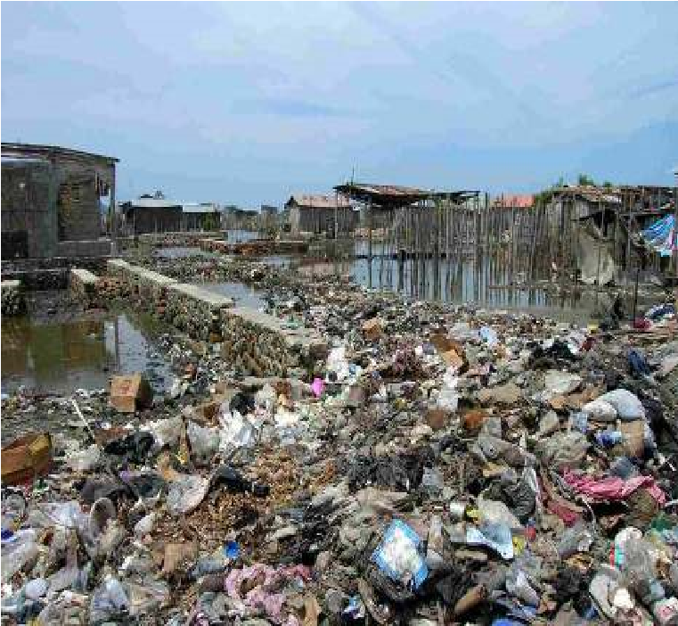

Industries produce huge amount of waste which contains toxic chemicals and pollutants which can cause air pollution and damage to us and our environment. They contain pollutants such as lead, mercury, sulphur, asbestos, nitrates and many other harmful chemicals. Many industries do not have proper waste management system and drain the waste in the fresh water which goes into rivers, canals and later in to sea. The toxic chemicals have the capability to change the color of water, increase the amount of minerals, also known as Eutrophication, change the temperature of water and pose serious hazard to water organisms.

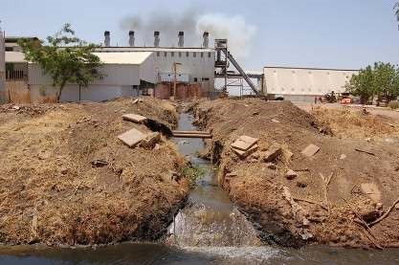

#### 03.Agricultural Discharges

Chemical fertilizers and pesticides are used by farmers to protect crops from insects and bacterias. They are useful for the plants growth. However, when these chemicals are mixed up with water produce harmful for plants and animals. Also, when it rains, the

chemicals mixes up with rainwater and flow down into rivers and canals which pose serious damages for aquatic animals.

#### 04.Accidental Oil leakage

Oil spill pose a huge concern as large amount of oil enters into the sea and does not dissolve with water; there by opens problem for local marine wildlife such as fish, birds and sea otters. For e.g.: a ship carrying large quantity of oil may spill oil if met with an accident and can cause varying damage to species in the ocean depending on the quantity of oil spill, size of ocean, toxicity of pollutant.

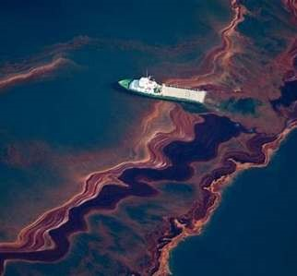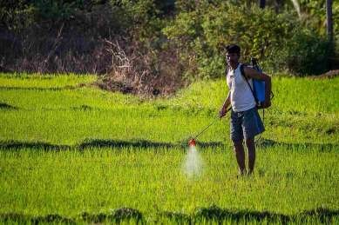

#### 05.Radioactive waste

Nuclear energy is produced using nuclear fission or fusion. The element that is used in production of nuclear energy is Uranium which is highly toxic chemical. The nuclear waste that is produced by radioactive material needs to be disposed off to prevent any nuclear accident. Nuclear waste can have serious environmental hazards if not disposed

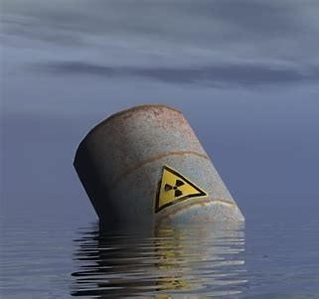

off properly. Few major accidents have already taken place in Russia and Japan.

#### 06.Thermal Pollutants

These pollutants include the waste chiefly from atomic, nuclear and thermal power plants. The discharge of un-utilised heat is highest in the thermal power plants which adversely affect the aquatic environment. Apart from electric power plants, various industries with cooling requirement contribute to thermal loading. Recently it is reported that about 20% more heat is given to cooling waters in nuclear power plants than fossil fuel plants of equivalent size.

#### 07.Mining activities

Mining is the process of crushing the rock and extracting coal and other minerals from underground. These elements when extracted in the raw form contains harmful chemicals and can increase the amount of toxic elements when mixed up with water which may result in health problems. Mining activities emit several metal waste and sulphides from the rocks and is harmful for the water.

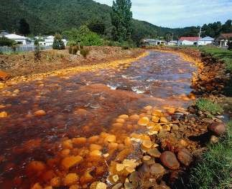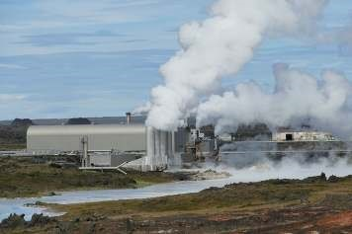

#### 08. Marine dumping

The garbage produce by each household in the form of paper, aluminum, rubber, glass, plastic, food if collected and deposited into the sea in some countries. These items take from 2 weeks to 200 years to decompose. When such items enters the sea, they not only cause water pollution but also harm animals in the sea.

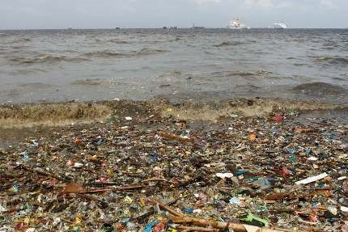

#### 09.Leakage from sewer lines

A small leakage from the sewer lines can contaminate the underground water and make it unfit for the people to drink. Also, when not repaired on time, the leaking water can come on to the surface and become a breeding ground for insects and mosquitoes.

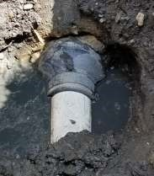

#### 10.Underground storage leakage

Transportation of coal and other petroleum products through underground pipes is well known. Accidentals leakage may happen anytime and may cause damage to environment and result in soil erosion.

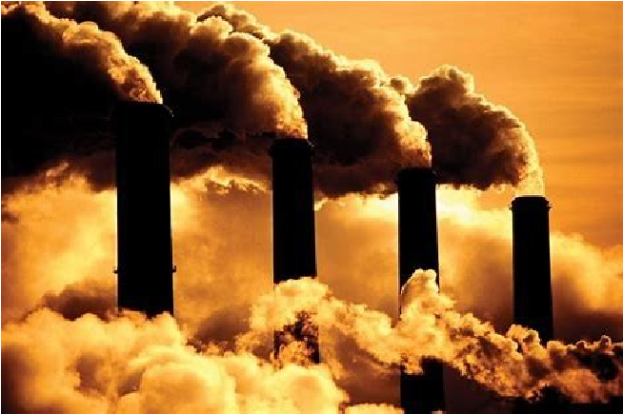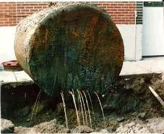

#### 11.Burning of fossil fuels

Fossil fuels like coal and oil when burnt produce substantial amount of ash in the atmosphere. The particles which contain toxic chemicals when mixed with water vapor result in acid rain. Also, carbon dioxide is released from burning of fossil fuels which result in global warming.

#### 12.Global warming

An increase in earth’s temperature due to greenhouse effect results in global warming. It increases the water temperature and result in death of aquatic animals and marine species which later results in water pollution.

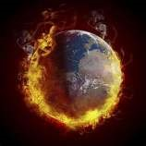

### Effects of Water Pollution

Water pollution damages human health makes our living conditions precarious and threatens life on the planet.

#### 1. Effects on aquatic ecosystem

* Polluted water reduces Dissolved Oxygen (DO) content, thereby,eliminates sensitive organisms like plankton, molluscs and fish etc.
* Biocides, polychlorinated biphenyls (PCBs) and heavy metalsdirectly eliminate sensitive aquatic organisms.
* Hot waters discharged from industries, when added to waterbodies, lowers its DO content.

#### 2. Effects on human health

* The polluted water usually contains pathogens like virus, bacteria,parasitic protozoa and worms; therefore, it is a source of water borne diseases like **jaundice**, **cholera**, **typhoid**, **arnoebiasis** etc.
* Mercury compounds in waste water areconverted by bacterial action into extremely

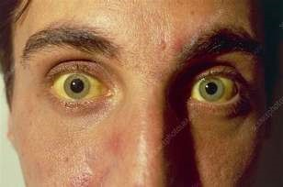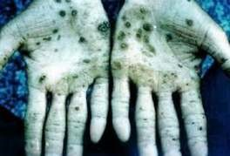

toxic methyl mercury, which can cause numbness of limbs, lips and tongue,

deafness, blurring of vision and mental derangement.

* Groundwater contains high levels of arsenic. As a result, the blackbruises on the hands and soles of the feet are called **blackfoot disease**.
* 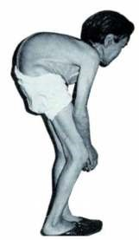Water contaminated with cadmium can cause **itai itai** disease also called ouch-ouch disease (a painful disease of bones and joints) and cancer of lungs and liver.
* The compounds of lead cause**anaemia**, headache, loss of muscle power and bluish line around the gum.



* A crippling deformity called

Minamata disease due to

consumption of fish captured from mercury contaminated **Minamata** Bay in Japan was detected in 1952.

#### 3. Hazards of ground water pollution

* Presence of excess nitrate in drinking water is dangerous for humanhealth and may be fatal for infants.
* Excess nitrate in drinking water reacts with haemoglobin to formnon-functional methaemoglobin, and impairs oxygen transport. This condition is called methaemoglobinemia or blue baby syndrome.
* Excess fluoride in drinking water causes neuro- muscular disorders,gastro-intestinal problems, teeth deformity, hardening of bones and stiff and painful joints (skeletal fluorosis).
* High concentration of fluoride ions is present in drinking water in

13 states of India. The maximum level of fluoride, which the human body can tolerate is 1.5 parts per million (mg/1 of water). Long term ingestion of fluoride ions causes fluorosis.

* Over exploitation of ground water may lead to leaching of arsenicfrom soil and rock sources and contaminate ground water. Chronic exposure to arsenic causes lack foot disease. It also causes. Diarrhoea, Peripheral neuritis, hyperkeratosis and also lung and skin cancer.
* Arsenic contamination is a serious problem (in tube well dug areas)m the Ganges Delta, west Bengal causing serious arsenic poisoning to large numbers of people. A 2007 study found that over 137 million people in more than 70 countries are probably affected by arsenic poisoning of drinking water.

#### 4. Biological Magnification

Heavy metal is harmful to species. When it inters in the food chain, harms all the species in the chain through increasing concentration of toxicants or pollutants in different trophic levels of the food chain, which is called biological magnification. Common examples of heavy metals are Mercury and DDT. These toxic materials that are ingested by the organisms cannot be metabolized or excreted. And,

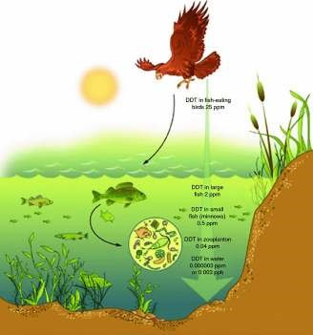

therefore they are passed on to the other trophic levels. Gradually as they go higher up the trophic levels, the concentration of these toxicants increases; thereby causing immense damage to the organisms. The concentration of DDT in fish-eating birds disturbs the calcium metabolism, thereby leading to thinner egg shells and a gradual decline in the bird population.

#### 5. Eutrophication

Soaps, phosphates (alkalis) of detergents mixed with the water of closed ponds, reservoirs, cause large amounts of algae, weeds, and weeds to grow. As a result, the amount of dissolved oxygen in the water decreases and fish and aquatic animals die. This is called Eutrophication.

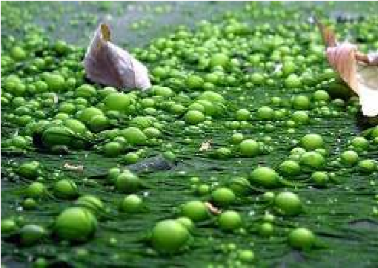

#### 6. Algal Bloom

Excessive algal bloom is harmful. Some algae are toxic to human beings and living organisms. Large amounts of nutrients in the water are the main cause of harmful planktonic growth. They ultimately cause the deterioration of water quality along with the decline in fish population.

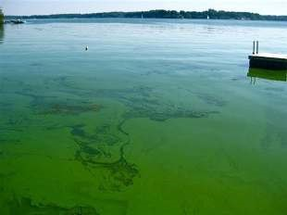

### Control of Water Pollution

1. Administration of water pollution controlshould be in the hands of state or central government.

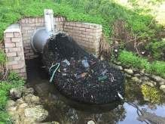

1. Scientific techniques should be adopted forenvironmental control of catchment areas of rivers, ponds or streams.
2. Industrial plants should bebased on recycling operations as it helps prevent disposal of wastes into natural waters but also extraction of products from

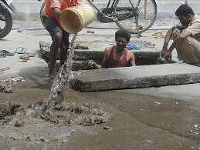

waste.

1. Plants, trees and forests control pollution asthey act as natural air conditioners.
2. Trees are capable of reducing sulphur dioxideand nitric oxide pollutants and hence more trees should be planted.
3. No type of waste (treated, partially treated oruntreated) should be discharged into any natural water body. Industries should develop closed loop water supply schemes and domestic sewage must be used for irrigation.
4. Qualified and experienced people must be consulted from time totime for effective control of water pollution.
5. Public awareness must be initiated regarding adverse effects ofwater pollution using the media.
6. Laws, standards and practices should beestablished to prevent water pollution and these laws should be modified from time to time based on current requirements and technological advancements.

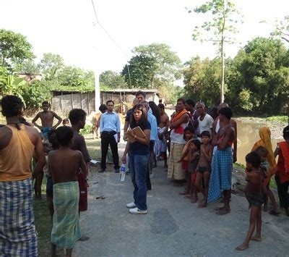

1. Basic and applied research in publichealth engineering should be encouraged.

**Precision irrigation** :-

Waste water doesn't have to be waste, it can become an asset. Existing techniques cause a lot of wastage of water. However, with precision irrigation, water reaches the crops directly, and therefore it doesn't come in contact with contaminants, subsequently resulting in preventing water from turning into waste.

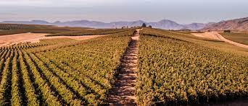msc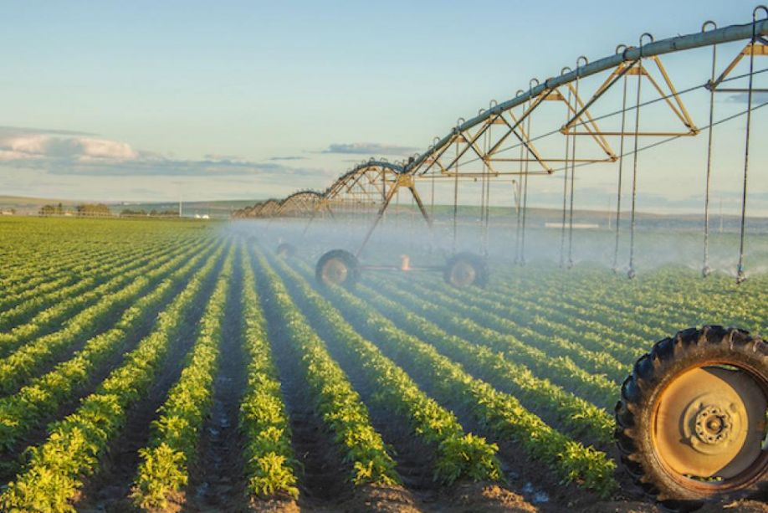  
**Adsorption :-**

Adsorption is a wastewater purification technique used to remove a variety of compounds from industrial wastewater. Adsorption is most commonly used to remove non-degradable organic compounds from groundwater, drinking water preparation, process water, or as a tertiary cleansing step after biological water purification.

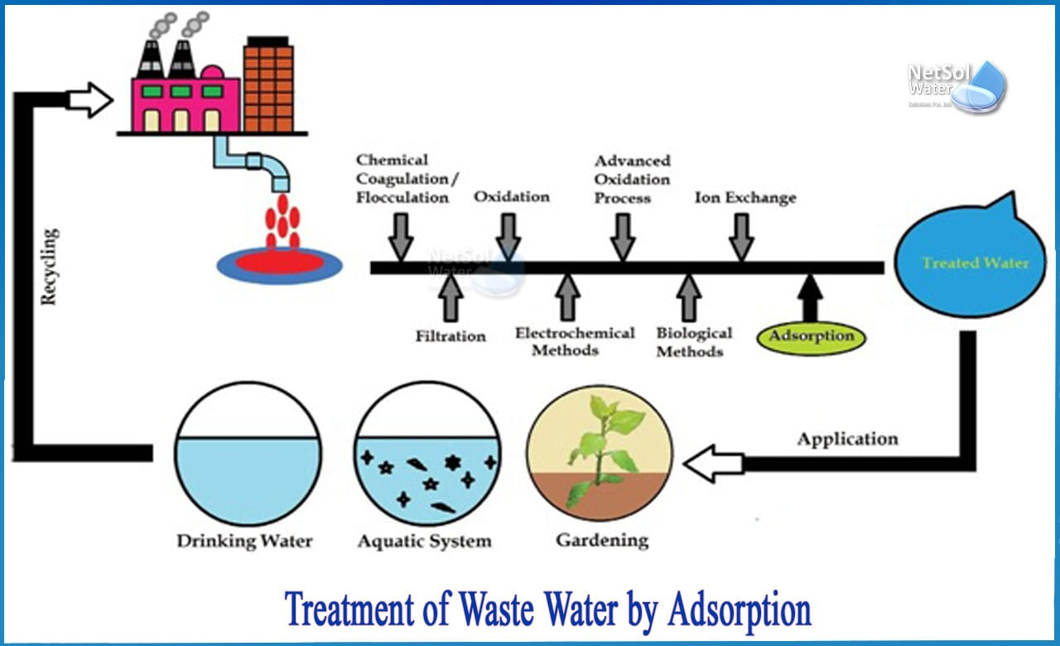

**Bio-Remediation :-**

Water pollution can be monitored and by measuring the biological oxygen demand. Bioremediation has been used to remove agricultural chemicals that leach from soil into groundwater and the subsurface. And also It is used in the removal of contaminants, pollutants, and toxic metals and oxides from water, and other environments.

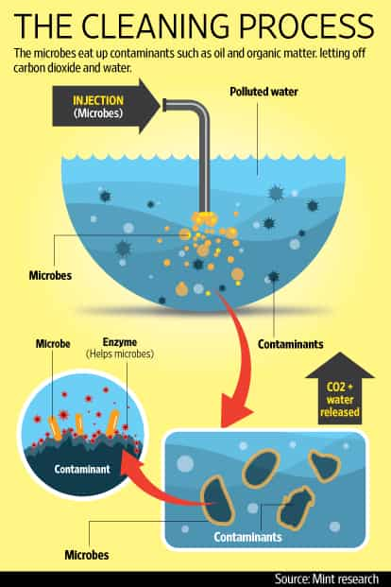

**Firebooms :-**

Fire booms are a specialised containment boom, These Containment booms are specially designed floating barriers that are used to prevent an oil or chemical spill from moving freely across a water surface. Fire booms are used to contain large spills in a limited area so that the oil can be burned in a controlled way, thus eliminating the pollutant from the water. 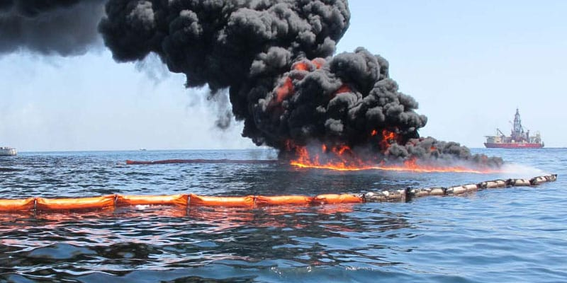

# OBJECTIVES

* Prohibit the discharge of toxic pollutants in quantities that might adversely affect the environment
* Construct publicly owned waste-treatment facilities with federal financial assistance
* Establish waste-treatment management plans within each state
* Establish the technology necessary to eliminate the discharge of pollutants
* Develop and implement programs for the control of nonpoint sources of pollution to enable the goals of the act to be met

### CONCLUSIONS

Water pollution is one of the major environmental pollution, which destroys the environment, animals and our daily comfortable life. So we must be aware about water pollution as we are all the reason behind it.

As a student we should understand this world wide problem of water pollution and think about its remedy. And we should convince others about this.